Options Hair Studio &Spa
Bridal Contract
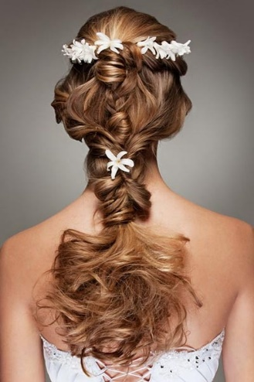

Thank you for choosing us for your beauty needs. We look forward to helping you create your special day.

Wedding Day
The Bride:
Bridal Hair Consultation $100
Day-of Bridal Hair with prior consultation $150
Day-of Bridal hair without consultation $400

Bridal Makeup Consultation $100
Day-of Bridal Makeup with prior consultation $150
Day-of Bridal Makeup without consultation $200
Additional Time in 30 minute units $30

Bridal Party:
Event Hair $125
Event Makeup Application $100
Eyelash Application- Strip Lashes $20
Flower Girl Hair- 10 and younger $60
Flower Girl Makeup – 10 and younger $45

Contract Information:

- Signed bridal contracts are required with a 50% deposit to secure wedding day appointments.
- The remaining balance must be paid 2 weeks prior to wedding date in one transaction. (Please Note: Changes CANNOT be made the day of services. If changes are needed please inform us 2 weeks before service date)
- Bridal appointments are held to a 30-day cancellation policy. Non-Cancellation will result in loss of deposit.
- Prices are subject to change based on length of time on service day. (30 min units)
- An automatic 25% service charge is added to all services.
- A travel fee of $150 per stylist.
Day of wedding:
- It is preferred that the bridal party arrives together to ensure that everyone is accounted for and to allow the stylists to stay on schedule.
- Please arrive with hair clean and dry.
- Blow drying/ extensions or hair pieces require more time and will be an additional charge.

In signing this contract, I have read and agree to the terms above. I understand that to secure the date requested, a deposit of 50% of full-service amount will be collected. If we are not given a 30-day notice of cancellation of date, the deposit will become nonrefundable.

Print Name: __________________________Date: __________
Signature: ___________________________________________

